Chapter 2. Time Series
The time series is a ubiquitous type of data set. It describes how some measurable feature (for instance, population, snowfall, or items sold) has changed over a period of time. Edward Tufte credits Johann Heinrich Lambert with the formal introduction of the time series to scientific literature in the 1700s.[2]
Because of its ubiquity, the time series is a good place to start when learning about visualization. With it we can cover:
- Acquiring a table of data from a text file
- Parsing the contents of the file into a usable data structure
- Calculating the boundaries of the data to facilitate representation
- Finding a suitable representation and considering alternatives
- Refining the representation with consideration for placement, type, line weight, and color
- Providing a means of interacting with the data so that we can compare variables against one another or against the average of the whole data set
For a straightforward data set, let’s turn to the U.S. Department of Agriculture (USDA) for statistics on beverage consumption. Government sites are a terrific resource for data; see Chapter 9 for more information about them and other sources of data.
Most methods will be implemented “by hand” in this section. Further down the line, we’ll make generalized code to handle different scenarios, such as reading a table from a file or placing labels and grid lines on a plot.

Milk, Tea, and Coffee (Acquire and Parse)
The data set we use was originally downloaded from http://www.ers.usda.gov/data/foodconsumption/foodavailqueriable.aspx.
The page lets you define a query to download a data set of interest. The site claims that the data is in Excel format, but a glance at the contents of the resulting file shows that it’s only an HTML file with an .xls extension that fools Excel into opening it. Rather than getting into the specifics of how to download and clean the data, I offer an already processed version here:
http://benfry.com/writing/series/milk-tea-coffee.tsv
This data set contains three columns: the first for milk, the second for coffee, and the third for tea consumption in the United States from 1910 to 2004.
To read this file, use this modified version of the Table class from the previous chapter:
http://benfry.com/writing/series/floattable.pde
The modified version handles data stored as float values, making it more efficient than the previous version, which simply converted the data whenever getString( ), getFloat( ), or getInt( ) were used.
Open Processing and start a new sketch. Add both files to the sketch by either dragging each into the editor window or using Sketch → Add File.

Cleaning the Table (Filter and Mine)
It’s necessary to determine the minimum and maximum of each of the columns in the pre-filtered data set. These values are used to properly scale plotted points to locations on the screen.
The FloatTable class has methods for calculating the min and max for the rows and columns. These methods are worth discussing because they are important in later code. The following example calculates the minimum value for a column (comments denote important portions of the code):
float getColumnMax(int col) {
// Set the value of m to the lowest possible value,
// so that the first value found will automatically be larger.
float m = MIN_FLOAT;

// Loop through each row.
for (int row = 0; row < rowCount; row++) {

// Only consider valid data elements (see later text).
if (isValid(row, col)) {
// Finally, check to see if the value
// is greater than the maximum found so far.
if (data[row][col] > m) {
m = data[row][col];
}
}
}
return m;
}
The isValid( ) method is important because most data sets have incomplete data. In the milk-tea-coffee.tsv file, all of the data is valid, but in most data sets (including others used in this chapter), missing values require extra consideration.
Because the values for milk, coffee, and tea will be compared against one another, it’s necessary to calculate the maximum value across all of the columns. The following bit of code does this after loading the milk-tea-coffee.tsv file:
FloatTable data;
float dataMin, dataMax;

void setup( ) {
data = new FloatTable("milk-tea-coffee.tsv");

dataMin = 0;
dataMax = data.getTableMax( );
}
Sometimes, it’s also useful to calculate the minimum value, but setting the minimum to zero provides a more accurate comparison between the three data sets. The minimum for this data set is 5.1, and the values for the tea column hover around 6, so using 5.1 as the dataMin value would produce a chart that looked as though the beverage history included periods of no (or nearly no) tea consumption in the U.S. In addition, if the value is 6, it’s important that the relative difference seen by the viewer is not just 0.9, but that it shows the full range from 0 up to 5.1 and how it compares to a value of 6.
Each row name specifies a year, which will be used later to draw labels on the plot. To make them useful in code, it’s also necessary to get the minimum and maximum year after converting the entire group to an int array. The getRowNames( ) method inside FloatTable returns a String array that can be converted with the int( ) casting function:
FloatTable data;
float dataMin, dataMax;int yearMin, yearMax;
int[] years;

void setup( ) {
data = new FloatTable("milk-tea-coffee.tsv");
years = int(data.getRowNames( ));
yearMin = years[0];
yearMax = years[years.length - 1];

dataMin = 0;
dataMax = data.getTableMax( );
}

A Simple Plot (Represent and Refine)
To begin the representation, it’s first necessary to set the boundaries for the plot location. The plotX1, plotY1, plotX2, and plotY2 variables define the corners of the plot. To provide a nice margin on the left, set plotX1 to 50, and then set the plotX2 coordinate by subtracting this value from width. This keeps the two sides even, and requires only a single change to adjust the position of both. The same technique is used for the vertical location of the plot:
FloatTable data;
float dataMin, dataMax;float plotX1, plotY1;
float plotX2, plotY2;

int yearMin, yearMax;
int[] years;

void setup( ) {
size(720, 405);

data = new FloatTable("milk-tea-coffee.tsv");

years = int(data.getRowNames( ));
yearMin = years[0];
yearMax = years[years.length - 1];

dataMin = 0;
dataMax = data.getTableMax( );

// Corners of the plotted time series
plotX1 = 50;
plotX2 = width - plotX1;
plotY1 = 60;
plotY2 = height - plotY1;

smooth( );
}
Next, add a draw( ) method that sets the background to a light gray and draws a filled white rectangle for the plotting area. That will make the plot stand out against the background, rather than a color behind the plot itself—which can muddy its appearance.
The rect( ) function normally takes the form rect(x, y, width, height), but rectMode(CORNERS) changes the parameters to rect(left, top, right, bottom), which is useful because our plot’s shape is defined by the corners. Like other methods that affect drawing properties, such as fill( ) and stroke( ), rectMode( ) affects all geometry that is drawn after it until the next time rectMode( ) is called:
void draw( ) {
background(224);

// Show the plot area as a white box.
fill(255);
rectMode(CORNERS);
noStroke( );
rect(plotX1, plotY1, plotX2, plotY2);

strokeWeight(5);
// Draw the data for the first column.
stroke(#5679C1);
drawDataPoints(0);
}

// Draw the data as a series of points.
void drawDataPoints(int col) {
int rowCount = data.getRowCount( );
for (int row = 0; row < rowCount; row++) {
if (data.isValid(row, col)) {
float value = data.getFloat(row, col);
float x = map(years[row], yearMin, yearMax, plotX1, plotX2);
float y = map(value, dataMin, dataMax, plotY2, plotY1);
point(x, y);
}
}
}

Labeling the Current Data Set (Refine and Interact)
Missing from the previous code is an indicator of the currently visible column of data (whether milk, tea, or coffee) and a means to swap between each of the three. For this, we add a variable to keep track of the current column, and another for the font used for the title. And few lines of code are added to the draw( ) method to write the name of the column with the text( ) method:
FloatTable data;
float dataMin, dataMax;

float plotX1, plotY1;
float plotX2, plotY2;int currentColumn = 0;
int columnCount;

int yearMin, yearMax;
int[] years;

PFont plotFont;

void setup( ) {
size(720, 405);
data = new FloatTable("milk-tea-coffee.tsv");
columnCount = data.getColumnCount( );

years = int(data.getRowNames( ));
yearMin = years[0];
yearMax = years[years.length - 1];

dataMin = 0;
dataMax = data.getTableMax( );

// Corners of the plotted time series
plotX1 = 50;
plotX2 = width - plotX1;
plotY1 = 60;
plotY2 = height - plotY1;

plotFont = createFont("SansSerif", 20);
textFont(plotFont);

smooth( );
}

void draw( ) {
background(224);

// Show the plot area as a white box.
fill(255);
rectMode(CORNERS);
noStroke( );
rect(plotX1, plotY1, plotX2, plotY2);

// Draw the title of the current plot.
fill(0);
textSize(20);
String title = data.getColumnName(currentColumn);
text(title, plotX1, plotY1 - 10);

stroke(#5679C1);
strokeWeight(5);
drawDataPoints(currentColumn);
}
The text( ) line draws the text 10 pixels above plotY1, which represents the top of the plot, and the drawDataPoints( ) line uses currentColumn instead of just 0. Results are shown in Figure 4-2.
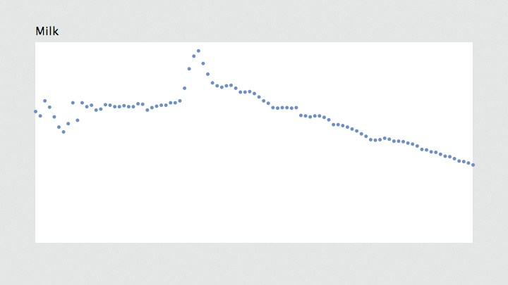
Figure 4-2. Time series with data set labeled
The createFont( ) function is used to create a font from one of the built-in typefaces. The built-in typefaces are Serif, SansSerif, Monospaced, Dialog, and DialogInput; they map to the default fonts on each operating system. On Mac OS X, for instance, SansSerif maps to Lucida Sans, whereas on Windows it maps to Arial. The default fonts are useful when you don’t want to deal with the Create Font tool, but the font choices are not particularly inspiring, and they don’t guarantee consistent output across different operating systems. For instance, making pixel-level decisions with a built-in font is a bad idea because the shaping and spacing of the characters can be significantly different on other operating systems.
One advantage of using createFont( ) is that the text will look smooth at any size, unlike a font used with loadFont( ), which may be distorted as it is resized.
It is possible to use createFont( ) to specify something besides a built-in font, but there’s no guarantee that the font will be installed on another user’s system. This can be useful for testing, after which you can use the Create Font tool before deployment. The name of a font used by createFont( ) should be identical to how it is listed in the Create Font tool. You can also get a list of the available fonts with the PFont.list( ) method, which returns a String array. The following will print the list of all available fonts to the console:
println(PFont.list( ));

Tip
If you have a lot of fonts installed on your system, there might be a long delay before they are listed.
The createFont( ) method can also be used with a TrueType (.ttf) or OpenType (.otf) file added to the data folder. Most TrueType fonts will work, but OpenType support varies by platform. Be mindful of copyrighted fonts when using this method in a sketch for public distribution.
A simple means of swapping between columns of data is to add a keyPressed( ) method, which will automatically run any time a key is pressed:
void keyPressed( ) {
if (key == '[') {
currentColumn--;
if (currentColumn < 0) {
currentColumn = columnCount - 1;
}
} else if (key == ']') {
currentColumn++;
if (currentColumn == columnCount) {
currentColumn = 0;
}
}
}
This method will rotate through the columns as the user presses the [ and ] (bracket) keys. When the number gets too big or too small, it wraps around to the beginning or end of the list. Because columnCount is 3, the possible currentColumn values are 0, 1, and 2. So, when currentColumn reaches a value less than zero, it wraps around to 2 (columnCount - 1).

Drawing Axis Labels (Refine)
An unlabeled plot has minimal utility. It clearly displays relative up or down swings, but without a sense of the time period or amounts to indicate the degree of swing, it’s impossible to know whether values have changed by, say, 5% or 50%. And some indication is required to explain that the horizontal axis represents the year and the vertical axis represents actual volumes: the amount consumed of a particular beverage, measured in gallons per capita per year.
There are clever (and complicated) means of selecting intervals, but for this project, we will pick the interval by hand. Choosing a proper interval and deciding whether to include major and minor tick marks depends on the data, but a general rule of thumb is that five intervals is at the low end, and more than ten is likely a problem. Too many labels make the diagram look like graph paper, and too few suggests that only the minimum and maximum values need to be shown.
The most important consideration is the way the data is used. Are minute, year-by-year comparisons needed? Always use the fewest intervals you can get away with, as long as the plot shows the level of detail the reader needs. Sometimes no labels are necessary—if values are only meant to be compared against one another. For instance, you might dispense with labels if you want to show only upward and downward trends. Other factors, such as the width of the plot, also play a role, so determining the correct level of detail usually requires a little trial and error.

Year Labels
Creating the year axis is straightforward. The data ranges from 1910 to 2004, so an interval of 10 years means marking 10 individual years: 1910, 1920, 1930, and so on, up to 2000. Add the yearInterval variable to the beginning of the code before setup( ):
int yearInterval = 10;
Next, add the following function to draw the year labels:
void drawYearLabels( ) {
fill(0);
textSize(10);
textAlign(CENTER, TOP);
for (int row = 0; row < rowCount; row++) {
if (years[row] % yearInterval == 0) {
float x = map(years[row], yearMin, yearMax, plotX1, plotX2);
text(years[row], x, plotY2 + 10);
}
}
}
The fill color is set to black, the text size to 10, and the alignment to the middle so that the year number centers on the position of the data point for that year.
Two lines in this code deserve further consideration. The first is the line that makes use of the %, or modulo, operator. A modulo operation returns the remainder from a division. So, for example, 7 % 2 is equal to 1, and 8 % 5 equals 3. It’s useful for drawing labels because it provides a way to easily identify a year ending in 0. Dividing 1910 by 10 returns 0, so a label is drawn, whereas dividing 1911 by 10 produces 1, and so it continues until the loop reaches 1920, which also returns 0 when divided by 10.
A second parameter to textAlign( ) sets the vertical alignment of the text. The options are TOP, BOTTOM, CENTER, and BASELINE (the default). The TOP and CENTER parameters are straightforward. The BOTTOM parameter is the same as BASELINE when only one line of text is used, but for multiple lines, the final line will be aligned to the baseline, with the previous lines appearing above it. When only one parameter is used, the vertical alignment resets to BASELINE.
The resulting image is shown in Figure 4-3.
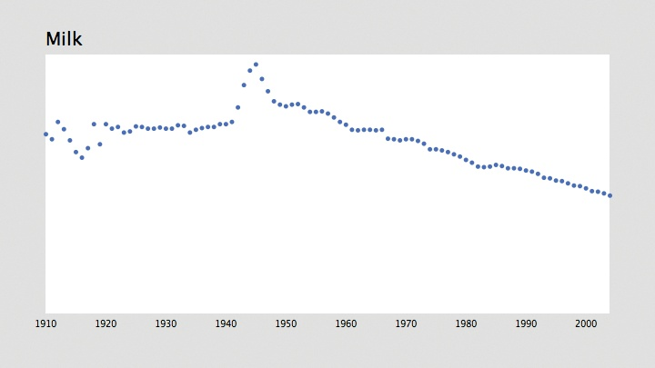
Figure 4-3. Time series with labeled x-axis

Tip
To draw text that does not bump into the elements above it, you need to know the height of the tallest character in the font. Typographers refer to this as the ascent. Traditionally, the ascent of a font is the height to the top of a capital H character. Characters such as the capital O or a capital B are in fact slightly taller than the letter H and dip slightly below the baseline—the bottom line from which text is drawn. The ascent value essentially refers to the optical height of the font, which is the height perceived by our eyes.
Simple grid lines can also help the presentation by identifying each interval. The following modifications add a grid to the drawYearLabels( ) function:
void drawYearLabels( ) {
fill(0);
textSize(10);
textAlign(CENTER, TOP);// Use thin, gray lines to draw the grid.
stroke(224);
strokeWeight(1);

for (int row = 0; row < rowCount; row++) {
if (years[row] % yearInterval == 0) {
float x = map(years[row], yearMin, yearMax, plotX1, plotX2);
text(years[row], x, plotY2 + 10);
line(x, plotY1, x, plotY2);
}
}
}
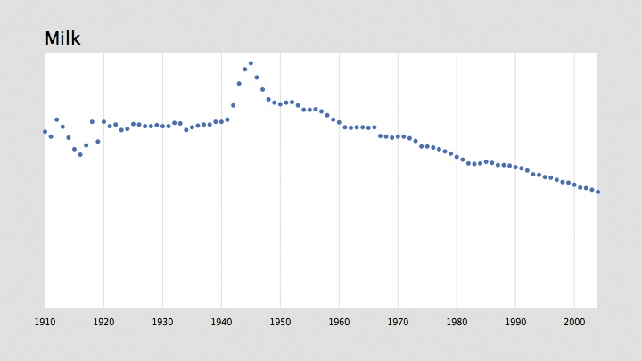
Figure 4-4. Time series with vertical grid
Notice that because the fill color does not affect lines, and a stroke color does not affect text, it is not necessary to use noFill( ) or noStroke( ) in this method.
With a separate method to draw the year labels, it makes sense to put the code that draws the title into its own method. The drawTitle( ) method takes this code from the draw( ) function. Just replace the title drawing code inside draw( ) with:
drawTitle( );
and then add the following method to the code:
void drawTitle( ) {
fill(0);
textSize(20);
textAlign(LEFT);
String title = data.getColumnName(currentColumn);
text(title, plotX1, plotY1 - 10);
}
Because the drawYearLabels( ) function changes the text alignment, a line is added to reset to textAlign(LEFT) before drawing the title. Otherwise, the title would appear centered at plotX1 on the next trip through the draw( ) method, inheriting the text alignment settings from the previous draw( ).

